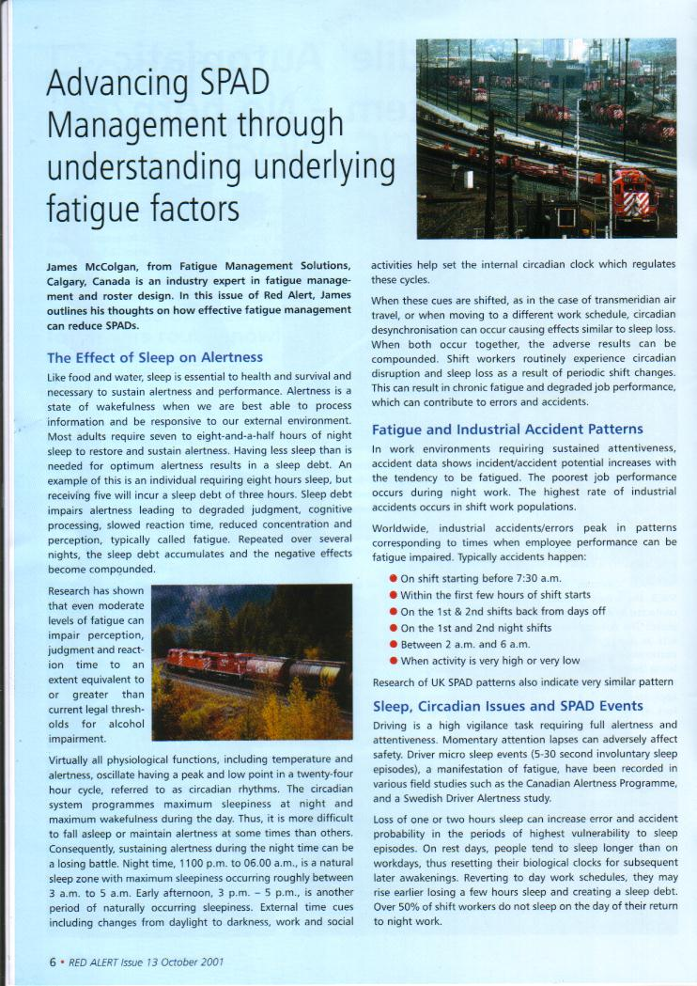


IDENTIFYING AND MANAGING HUMAN FACTOR SPAD PRECURSORS TO ADVANCE SAFETY



Paper prepared by
JAMES MCCOLGAN
MANAGING DIRECTOR
FATIGUE MANGEMENT SOLUTIONS LTD
CALGARY, CANADA
www.fatiguesolutions.ca

Have you ever ended a car journey not recalling the drive? You are not alone. Sustaining attentiveness and situational awareness is a challenge confronting transport operators from pilots to train drivers. Sedentary and routine work causing monotony compounded by shift work fatigue can compromise vigilance. These can have safety implications for train drivers, who require highly developed cognitive skills and constant attentiveness to monitor immediate conditions and plan ahead. Momentary inattentiveness can result in a SPAD.

Research shows that long-term task adaptation, long periods remaining sedentary in a stable environment, routine and repetitive tasks/workload can induce monotony, reducing attentiveness. Vehicle drivers in a stable environment become accustomed to a condition similar to habituation to inspection tasks, leading to automatic response impairing job concentration. (Schwab, 1957; Yoss, 1969)

Train drivers can also habituate to the repetitive nature of routine driving; becoming system monitors, all of which increases inattentiveness risk. In practical terms, following initial skills development, train driving becomes routine.

Driving experience increases confidence and competency and autopilot driving can result, whilst low workload, and repetitive tasks result in drivers’ attention not being fully engaged. Under such circumstances mental arousal (task focus/concentration) levels drop, monitoring checks are made less frequently, lapses in attention occur and the opportunity for skill-based human errors increases. One study found that inattention was implicated in 70% of all train accidents and near-misses. (Edkins and Pollock, 1997)

Shift work based fatigue compounds inattentiveness risk. Humans are poor at sustaining attentiveness when monotonous tasks coincide with fatigue zones. In work environments requiring sustained vigilance and attentiveness, accident and error levels increase with fatigue levels. (Dinges, 1989, 1992)

In the context of train driving, accidents or near accidents due to inattentiveness, leading to increased propensity for microsleep events, are not unusual. (Hashimoto, 1968; Hildebrandt et al., 1974) Swedish research of over 1,000 drivers found night and early morning shifts associated with shortened sleep (approximately 4-5 hours), causing extreme fatigue and on-duty microsleeps. (Åkerstedt et al, 1995)

Train driver research confirms the interaction of monotony and fatigue on attentiveness including:

- Japanese study analysing near-accidents/accidents found 17% were fatigue related, 79% of which occurred between midnight and 6 a.m. and occurred while driving along monotonous stretches of track. (Kogi & Ohta, 1975)

- Australian study of 100 accidents/near-accidents concluded the most significant causal factor was lack of alertness related to a high degree of monotony. (Edkins & Pollock, 1997)

Work environment and shift design are core elements of inattentiveness and human factor based SPAD precursor risk.

Conducting world-wide railway human factors work, the writer has interviewed hundreds of drivers. All advised situations of not recalling the last signal passed. Inattentiveness is real, requiring our ‘attention’.

Current ‘vigilance’ technology, including deadman’s controls, or even AWS, do not detect physiologically based attentiveness or alertness lapses. Drivers can deactivate these devices, responding to their audible warning alarms at extremely high levels of drowsiness and pre-empting their activation even when they have lost situational awareness of operating conditions and signals. (Howarth, Regan & Larson, 2000)

To fight monotony and drowsiness the writer has found drivers manipulate environmental stimulus levels through non-job focused activities including: standing, playing mental games, even singing. Absence organisational strategies to manage inattentiveness and fatigue, drivers apply ad hoc coping strategies. These only temporarily alleviate symptoms without addressing root causes and can exacerbate distraction, increasing SPAD risk.

Technical interventions have progressively reduced SPADs. A distinct pattern has now emerged – SPADs occurring early in the shift – including in early starts. Early shifts shorten sleep, increasing fatigue risk that, combined with monotony, can cause driver inattentiveness, while morning traffic levels increase the probability of encountering restrictive signals. This convergence of risk factors can increase SPAD risk.

SPAD management is about addressing driver risk of missing signals. Yet SPAD risk is not resolved solely at an individual level. Effective SPAD management must include review of: work organisation/environment; work scheduling; safety culture, and integration of human-centred practices promoting attentiveness and reducing fatigue. This may include: bio-roster design, applying roster design principles protecting alertness, operational needs, and promoting enhanced driver quality of life to proactively manage fatigue and human factor SPAD risk.

REFERENCES

Åkerstedt, T. (Ed.) (1995). “Work hours, sleepiness and accidents”. Journal of Sleep Research,4 (suppl. 2), whole issue.

Dinges, D.F. (1989). ‘The nature of sleepiness: Causes, contexts and consequences’. In Stunkard, A.J. and Baum, A. (eds). Perspectives in behavioural medicine: Eating, sleeping and sex. Hillsdale, NJ: Lawrence Erlbaum Associates, pp. 147-179.

Dinges, D.F. (1992). Probing the Limits of Functional Capability: The Effects of Sleep Loss on Short-Duration Tasks. In R.J. Broughton & R. Ogilvie (Eds.), Sleep, Arousal and Performance: Problems and Promises. Boston: Birkhäuser-Boston, Inc.

Edkins, G.D., & Pollock, C.M. (1997). The influence of sustained attention on railway accidents. Accident Analysis & Prevention, 29, 533-539.

Hashimoto, K. (1968) Unten-ji ni okeru seiriteki-kino no suii (Changes of physiological functions during driving). J. Trans. Med., 22: 281-284.

Hildebrandt, G. Rohmert, W., & Rutenfranz, J. (1974). 12 and 24 hour rhythms in error frequency of locomotive drivers and the influence of tiredness. Int J Chronobiol.2, 175-180.

Howarth, N., Regan, M., Larson, T. (2000), ‘The Effectiveness of Driver Vigilance Control Systems on Locomotives’, paper presented to Fourth International Conference on Fatigue and Transportation, Freemantle, 19-22 March, 2000

Kogi, K., & Ohta, T. (1975). Incidence of near accidental drowsing in locomotive driving during a period of rotation. J Hum Ergol. 4, 65-76.

Schwab, R.S. (1957) Factors in fatigue and stress in the operation of high-speed diesel passenger railway cars with only one driver present. Ergonomics, 1: 84-90.

Yoss, R.E. (1969). The sleepy driver: a test to measure ability to maintain alertness. Mayo Clin. Proc., 44: 769 – 783.

______________________________________________________________________________

